**Data Security  & Tableau Online**

**Problem statement**

Business wants to publish the report in Tableau Online and need to create users who can explore and view account. Create the accounts using the email ids and help users to get the desired accesses.

Create an user account with the email id EMAIL ID 1 and EMAIL ID 2 and give user 1 as explorer access and user 2 as viewer access

Create a group called iNeuron and add these users to the group. Give the custom access to the group and see what happens to the user access level once they are added to the group.

With the Admin access, try to explore the Ask Data option in the Tableau Online.

User 1 is a manager of Central region, he should only get access to Central region’s data.

 User 2 is a higher management and he should have access to all the locations.

**Solution**

Task 1

Go to User  >>  Add user by Email  >>  Provide Email id of someone's Tableau public account  >>  Assign site role.

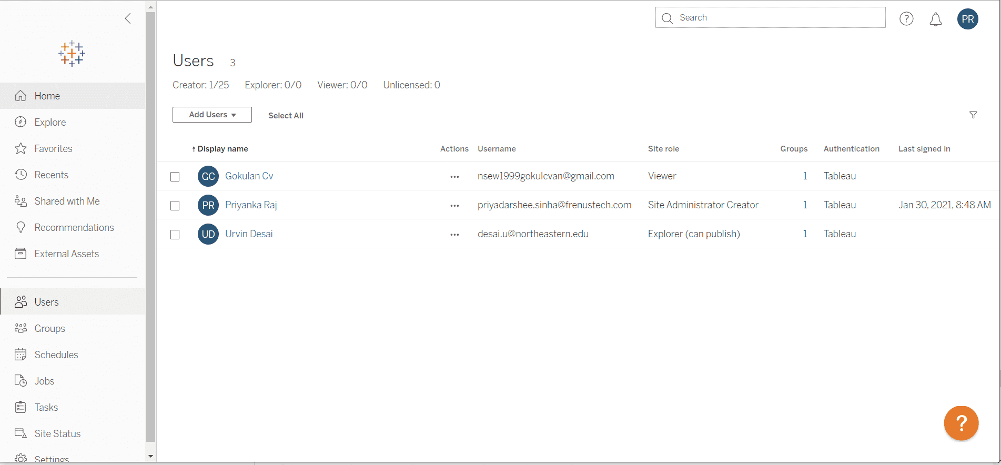

Go to your tableau desktop >> go to server >> publish workbook >> Tableau online >> supply credentials of your tableau online account >> fill required field >> edit the permission >> assign your user members their role >> publish

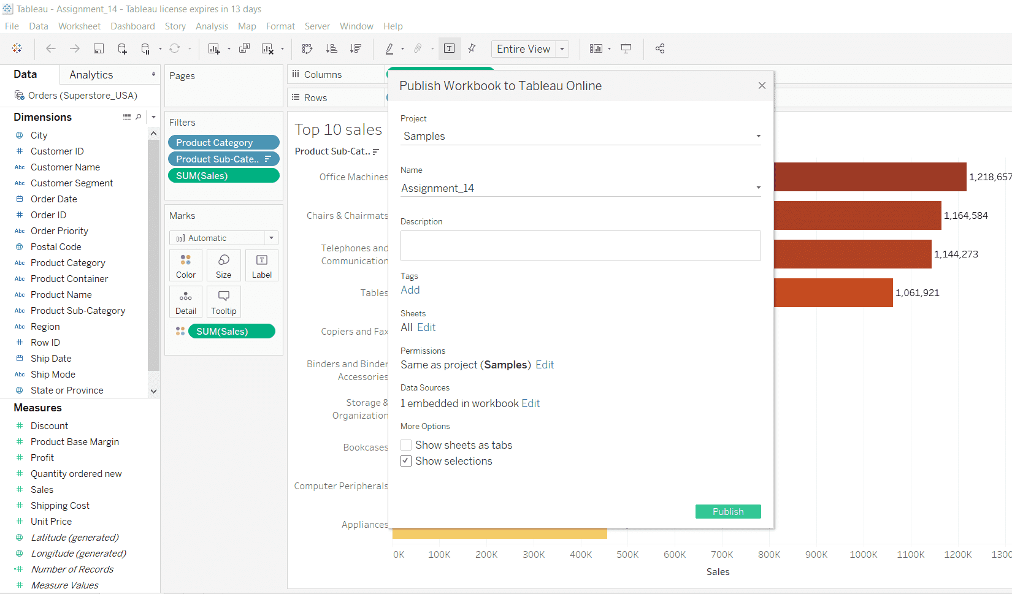

Go to one visual from your project >> click on Subscribe >> Give Group Name like iNeuron. >> Entire workbook >> and set format and schedule. and click on Subscribe.

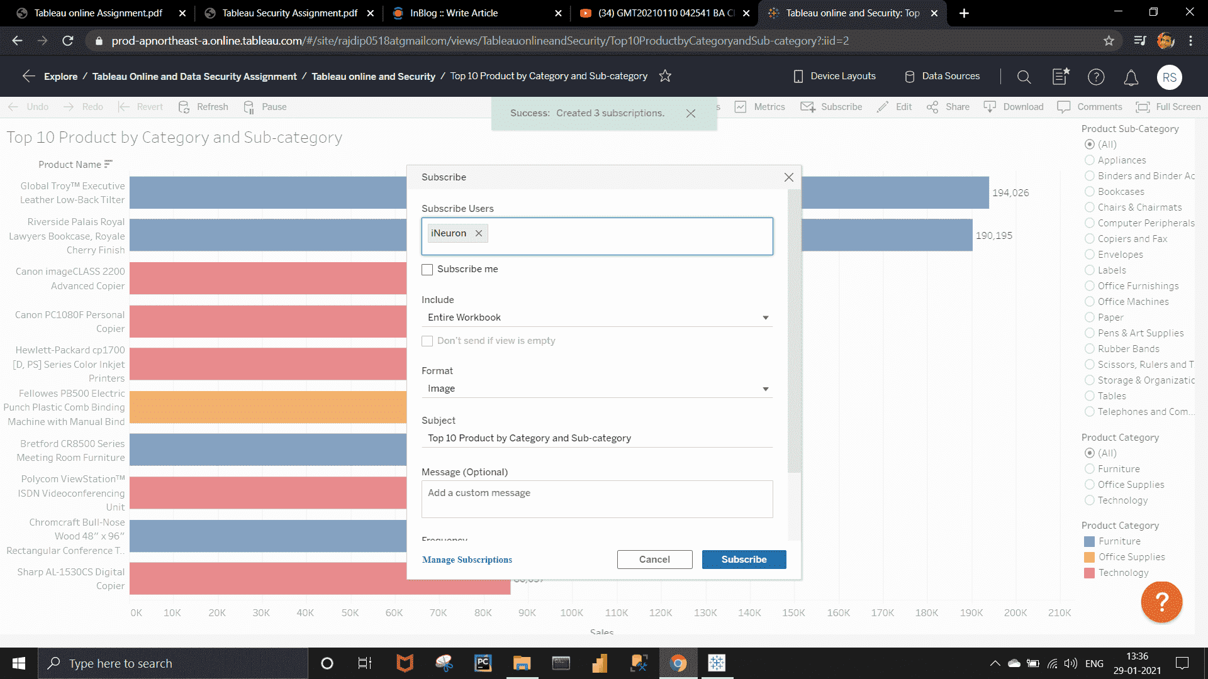

Again, Go to the dataset  >> Ask Data >> Write Your question.  >>  can save by click the save option from there.

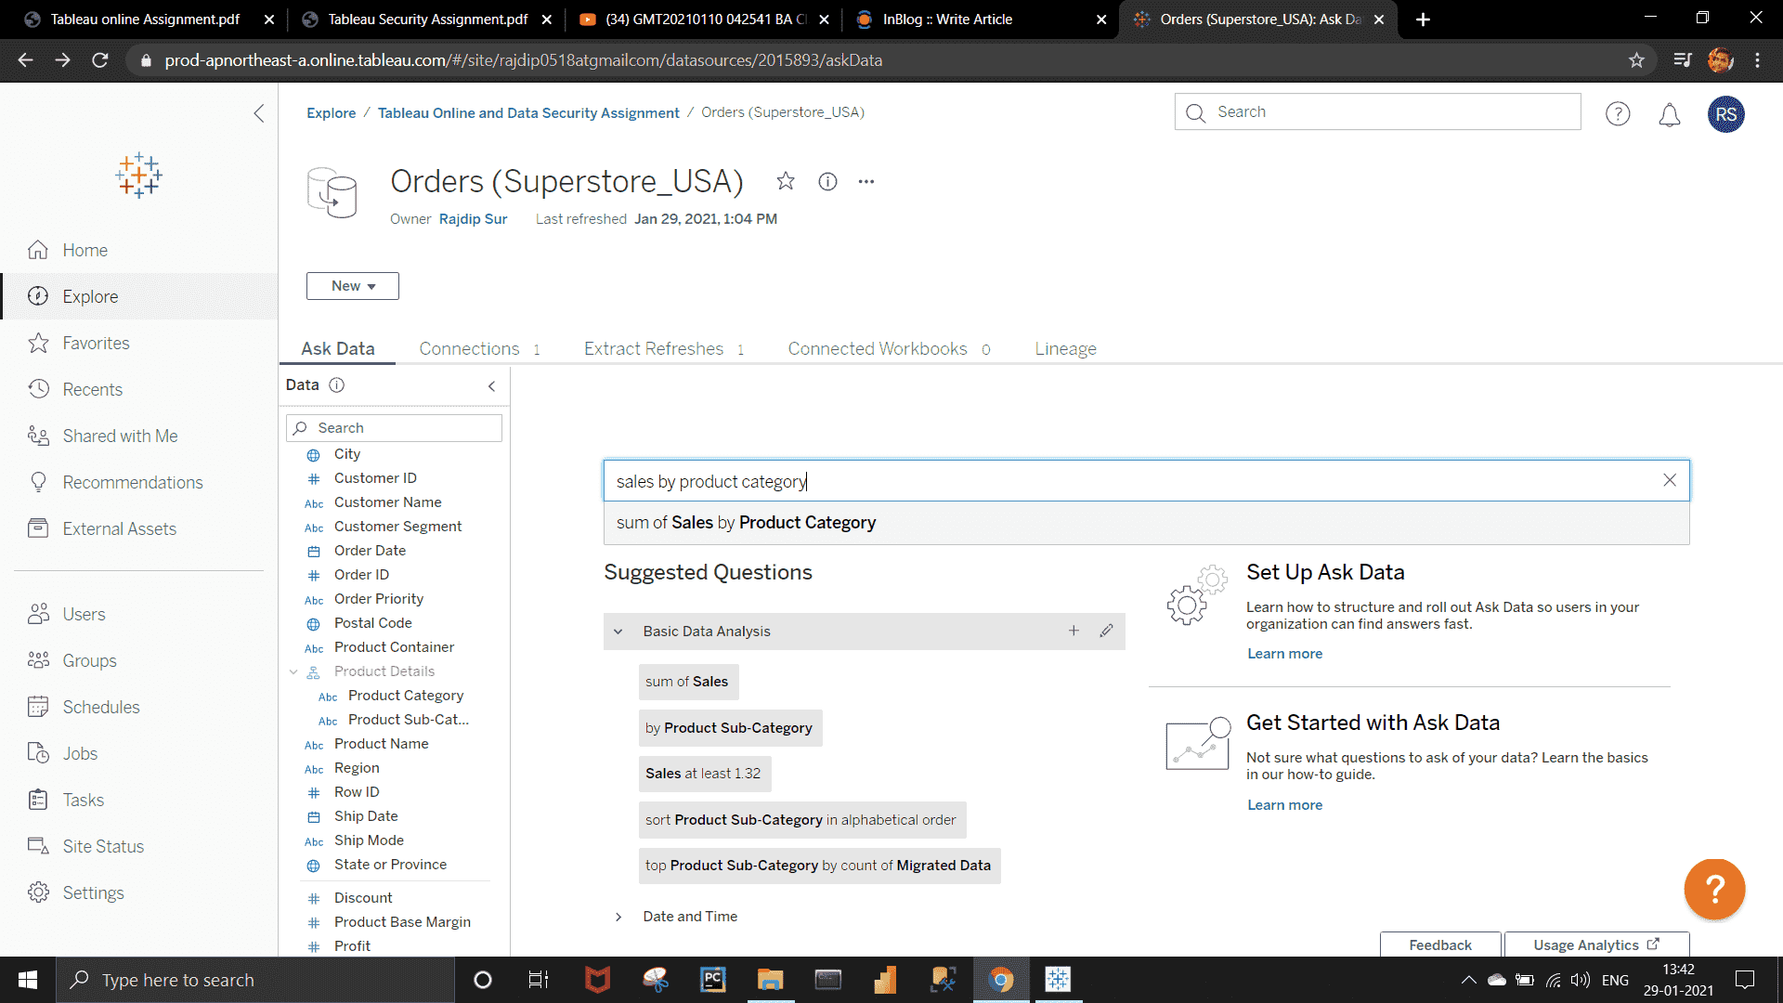

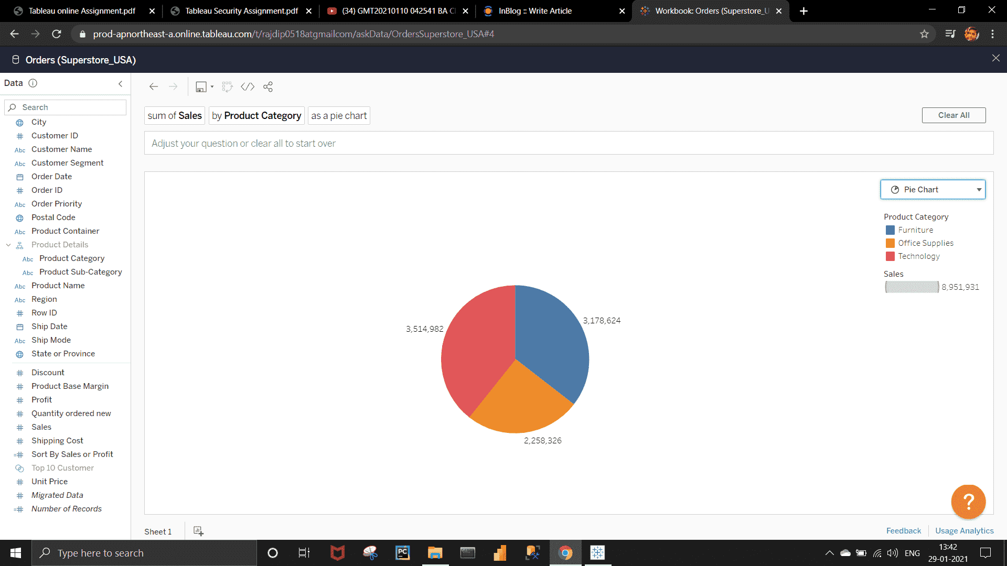

**NEED:-  
User 1 is a manager of Central region, he should only get access to Central region’s data.  
User 2 is a higher management and he should have access to all the locations.**

Go to your project visual >>  keep all region selected  >>   Go to subscribe  >>   Assign your higher manager's email id.  >>  Subscribe.

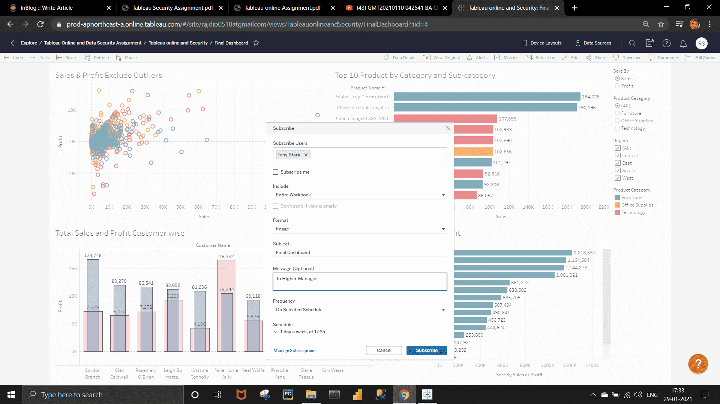

Similarly do the same think for the central region manager. Select only the Central region from filter and assign this for Central Region Management.

